**Diamond Shop System**

**Software Requirement Specification**

Project Code: <Code of the project>

Document Code: <Code of the document >– v<x.x>

**<Location, issued date of the Document>**

**Record of change**

*A - Added M - Modified D - Deleted

| **Effective Date** | **Changed Items** | **A* M, D** | **Change Description** | **New Version** |
| --- | --- | --- | --- | --- |
| 08/05/2024 | Initial | A | Add project overview |  |
| 10/05/2024 | Initial | A | Add context diagram, use case diagram |  |
| 11/05/2024 | Initial | A | Add erdDiagram |  |
|  |  |  |  |  |
|  |  |  |  |  |
|  |  |  |  |  |
|  |  |  |  |  |
|  |  |  |  |  |
|  |  |  |  |  |
|  |  |  |  |  |
|  |  |  |  |  |
|  |  |  |  |  |
|  |  |  |  |  |
|  |  |  |  |  |
|  |  |  |  |  |
|  |  |  |  |  |
|  |  |  |  |  |
|  |  |  |  |  |
|  |  |  |  |  |
|  |  |  |  |  |
|  |  |  |  |  |

**SIGNATURE PAGE**

**ORIGINATOR:** <Name> <Date>

<Position>

**REVIEWERS:** <Name> <Date>

<Position>

<Name, if it’s needed> <Date>

<Position>

**APPROVAL:** <Name> <Date>

<Position>

**TABLE OF CONTENTS**

**1** **Introduction 5**

1.1 Purpose………………………………………………………………………………………………………… 5

1.2 Scope…………………………………………………………………………………………………………… 5

1.3 Definitions, Acronyms, and Abbreviations…………………………………………………………… 5

1.4 References…………………………………………………………………………………………………… 5

1.5 Overview……………………………………………………………………………………………………… 6

**2** **Overall Description 7**

**3** **FUNCTIONAL Requirements 8**

3.1 <Use Cases Diagram> 8

3.2 < Use Case Name 1> 8

3.3 < Use Case Name 2> 9

**4** **NON-FUNCTIONAL Requirements 10**

4.1 Usability 10

4.2 Reliability 10

4.3 Performance 10

4.4 Supportability 11

4.5 Design Constraints 11

4.6 On-line User Documentation and Help System Requirements 11

4.7 Purchased Components 11

4.8 Interfaces 12

4.9 Licensing Requirements 12

4.10 Legal, Copyright, and Other Notices 12

4.11 Applicable Standards 12

**5** **Supporting Information 13**

# Introduction

*[The introduction of the* ***Software Requirements Specification (SRS)*** *provides an overview of the entire* ***SRS****. It includes the purpose, scope, definitions, acronyms, abbreviations, references, and overview of the* ***SRS****.]*

*[Note: The* ***SRS*** *document captures the complete software requirements for the system, or a portion of the system. Following is a typical* ***SRS*** *outline for a project using only traditional, natural-language style requirements—with* ***no use-case modeling.*** *It captures all requirements in a single document, with applicable sections inserted from the Supplementary Specifications (which would no longer be needed). For a template of an* ***SRS*** *using use-case modeling, which consists of a package containing Use Cases of the use-case model and applicable Supplementary Specifications and other supporting information, see rup_srsuc.dot.]*

*[Many different arrangements of an* ***SRS*** *are possible. Refer to [IEEE830-1998] for further elaboration of these explanations, as well as other options for* ***SRS*** *organization.]*

## Purpose

*[Specify the purpose of this SRS. The SRS fully describes the external behavior of the application or subsystem identified. It also describes nonfunctional requirements, design constraints, and other factors necessary to provide a complete and comprehensive description of the requirements for the software.]*

Diamond Shop System is a shopping management website that streamlines the shopping management process of a diamond business. The system is easy to use and the staffs needs little time to train. The system ensures high security and reliability, it helps alleviate the workload of the management and ease of online shopping. The system allows customer to buy diamond accessories based his/her needs and requirements. The managers and adminstrators allow to manage warranty card, promotion and point management system.

## Scope

*[A brief description of the software application that the SRS applies to, the feature or other subsystem grouping, what Use-Case model(s) it is associated with, and anything else that is affected or influenced by this document.]*

## Definitions, Acronyms, and Abbreviations

| Acronyms | Definition |
| --- | --- |
| SRS | Software Requirements Specification |
|  |  |
|  |  |
|  |  |
|  |  |

## References

## Overview

*[This subsection describes what the rest of the SRS contains and explains how the document is organized.]*

# Overall Description

*[This section of the SRS describes the general factors that affect the product and its requirements. This section does not state specific requirements. Instead, it provides a background for those requirements, which are defined in detail in Section 3, and makes them easier to understand. Include such items as:*

*• product perspective*

*• product functions*

*• user characteristics*

*• constraints*

*• assumptions and dependencies*

*• requirements subsets]*

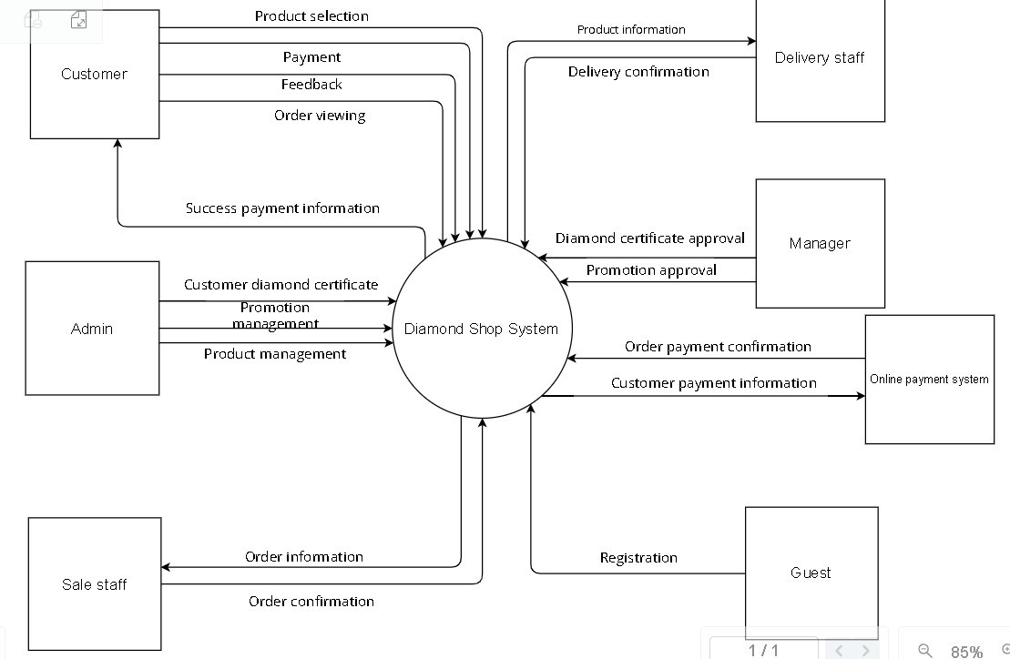

# FUNCTIONAL Requirements

## <Use Cases Diagram>

*[The main Use Case Diagrams of the system]*

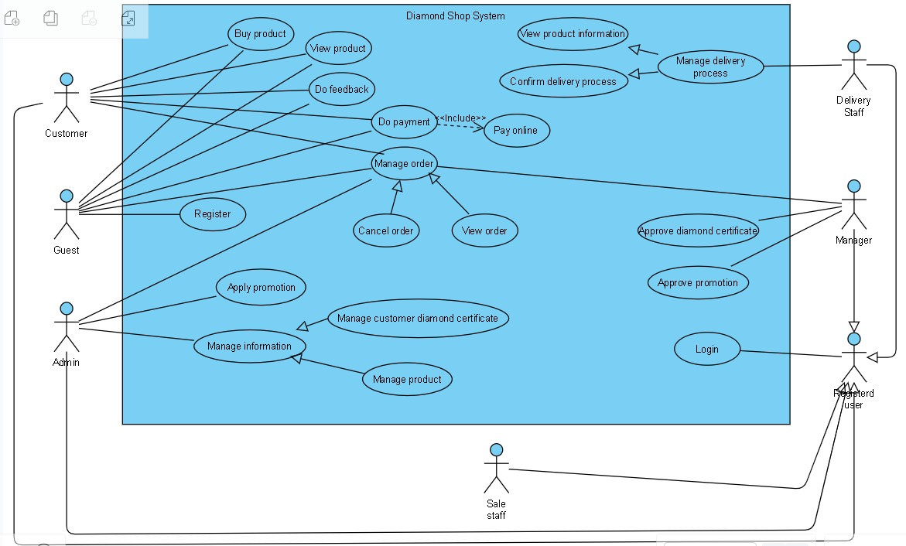

## < Use Case Name 1>

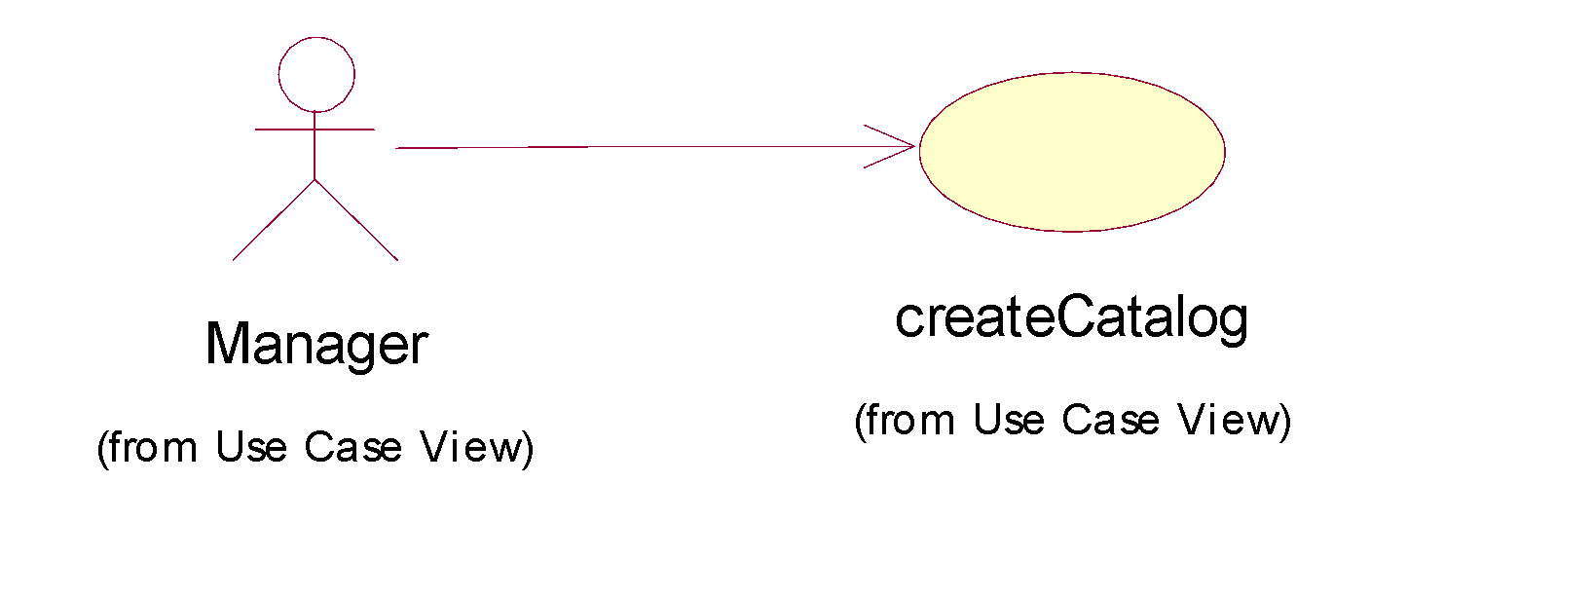

| **USE CASE-n SPECIFICATION** | | | | |
| --- | --- | --- | --- | --- |
| **Use-case No.** | <UC001> | **Use-case Version** | | <1.0> |
| **Use-case Name** | <Name> | | | |
| **Author** | <Members> | | | |
| **Date** | Dd/mm/yyyy | **Priority** | <High/Normal/Low> | |
| **Actor:**  *<Lit all actors>*  **Summary:**  *<Briefly describe the used case >*  **Goal:**  *<Briefly describe the goal of used case >*  **Triggers**  *<What does lead in using this case?>*  **Preconditions:**  *<List the required pre-conditions for using this case>*  **Post Conditions:**  *<List the required post-conditions for using this case>*  **Main Success Scenario:**  *<List the main steps for using this case to reach the goal successfully >*  **Alternative Scenario:**  *<List other steps for using this case to reach the goal in some alternative conditions >*  **Exceptions:**  *<List exceptions of this use case >*  **Relationships:**  *<List the relationships that use case relates to>*  **Business Rules:**  *<Any concern about the business>* | | | | |

## < Use Case Name 2>

…………………

# NON-FUNCTIONAL Requirements

*[This section describes the non-functional requirements of the system. Some examples are listed as below]*

## Usability

*[This section includes all those requirements that affect usability. For example,*

*specify the required training time for a normal users and a power user to become productive at particular operations*

*specify measurable task times for typical tasks or base the new system’s usability requirements on other systems that the users know and like*

*specify requirement to conform to common usability standards, such as IBM’s CUA standards Microsoft’s GUI standards]*

* The application must be intuitive and easy to use for all user roles, including administrators, managers, staffs, and customers.
* After 4 hours of training, all users can use all functions of the system easily.
* The system response time to user actions shall be no more than 3 seconds.
* The system shall have a user-friendly interface that is easy to learn and navigate for users with varying levels of technical expertise.
* The system shall provide clear and concise instructions for completing tasks.

### <Usability Requirement One>

*[The requirement description goes here.]*

## Reliability

*[Requirements for reliability of the system should be specified here. Some suggestions follow:*

*Availability—specify the percentage of time available ( xx.xx%), hours of use, maintenance access, degraded mode operations, and so on.*

*Mean Time Between Failures (MTBF) — this is usually specified in hours, but it could also be specified in terms of days, months or years.*

*Mean Time To Repair (MTTR)—how long is the system allowed to be out of operation after it has failed?*

*Accuracy—specifies precision (resolution) and accuracy (by some known standard) that is required in the system’s output.*

*Maximum Bugs or Defect Rate—usually expressed in terms of bugs per thousand lines of code (bugs/KLOC) or bugs per function-point( bugs/function-point).*

*Bugs or Defect Rate—categorized in terms of minor, significant, and critical bugs: the requirement(s) must define what is meant by a “critical” bug; for example, complete loss of data or a complete inability to use certain parts of the system’s functionality.]*

* The system shall provide a high reliability so that users will be able to access the system most of the time.
* The system will be available for 99% of the time between 6AM to 11:59PM Indochina Time, and 95% of the time between midnight to 5:59AM Indochina Time.
* Data loss due to system errors shall not exceed 0.01% per year.

### <Reliability Requirement One>

*[The requirement description.]*

## Performance

*[The system’s performance characteristics are outlined in this section. Include specific response times. Where applicable, reference related Use Cases by name.*

*Response time for a transaction (average, maximum)*

*Throughput, for example, transactions per second*

*Capacity, for example, the number of customers or transactions the system can accommodate*

*Degradation modes (what is the acceptable mode of operation when the system has been degraded in some manner)*

*Resource utilization, such as memory, disk, communications, and so forth.*

* The system shall be able to handle a concurrent load of 100 users without significant slowdown.
* The system shall generate reports containing diamond information within 5 minutes of receiving the request.
* The system response time for frequently accessed diamond data shall be less than 1 second.

### <Performance Requirement One>

*[The requirement description goes here.]*

*Interfaces*

## Supportability

*[This section indicates any requirements that will enhance the supportability or maintainability of the system being built, including coding standards, naming conventions, class libraries, maintenance access, and maintenance utilities.]*

* The system shall provide comprehensive online help documentation.
* The vendor shall provide technical support during business hours with a guaranteed response time of 4 hours or less.
* The system shall be designed in a modular way to facilitate future maintenance and upgrades.

### <Supportability Requirement One>

*[The requirement description goes here.]*

## Design Constraints

*[This section indicates any design constraints on the system being built. Design constraints represent design decisions that have been mandated and must be adhered to. Examples include software languages, software process requirements, prescribed use of developmental tools, architectural and design constraints, purchased components, class libraries, and so on.]*

### <Design Constraint One>

*[The requirement description goes here.]*

## On-line User Documentation and Help System Requirements

*[Describes the requirements, if any, for o-line user documentation, help systems, help about notices, and so forth.]*

## Purchased Components

*[This section describes any purchased components to be used with the system, any applicable licensing or usage restrictions, and any associated compatibility and interoperability or interface standards.]*

## Interfaces

*[This section defines the interfaces that must be supported by the application. It should contain adequate specificity, protocols, ports and logical addresses, and the like, so that the software can be developed and verified against the interface requirements.]*

### User Interfaces

*[Describe the user interfaces that are to be implemented by the software.]*

### Hardware Interfaces

*[This section defines any hardware interfaces that are to be supported by the software, including logical structure, physical addresses, expected behavior, and so on.]*

### Software Interfaces

*[This section describes software interfaces to other components of the software system. These may be purchased components, components reused from another application or components being developed for subsystems outside of the scope of this SRS but with which this software application must interact.]*

### Communications Interfaces

[Describe any communications interfaces to other systems or devices such as local area networks, remote serial devices, and so forth.]

## Licensing Requirements

*[Defines any licensing enforcement requirements or other usage restriction requirements that are to be exhibited by the software.]*

## Legal, Copyright, and Other Notices

*[This section describes any necessary legal disclaimers, warranties, copyright notices, patent notices, wordmark, trademark, or logo compliance issues for the software.]*

## Applicable Standards

*[This section describes by reference any applicable standard and the specific sections of any such standards which apply to the system being described. For example, this could include legal, quality and regulatory standards, industry standards for usability, interoperability, internationalization, operating system compliance, and so forth.]*

# Supporting Information

*[The supporting information makes the SRS easier to use. It includes:*

*Table of contents*

*Index*

*Appendices*

*These may include use-case storyboards or user-interface prototypes. When appendices are included, the SRS should explicitly state whether or not the appendices are to be considered part of the requirements.]*